Customers with guide dogs
  - A guide for taxi drivers
In B.C., people with disabilities have a right to access services like taxis just like everyone else. This includes customers with guide dogs.

Do treat your customer with respect

Say hello, ask if they require assistance, be professional and courteous.

Don’t ask for certification
Customers DO NOT need to show any kind of proof or certification for their guide dog—it's the law.

Do speak directly to your customer
Be sure to use your voice as your customer may not be able to see your facial expressions or hand gestures.

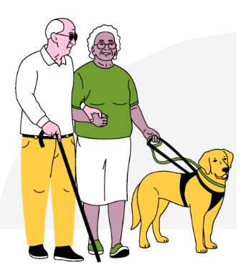
Don’t interact with the guide dog
Don't touch or speak to the guide dog. They are working and must not be distracted.

It is illegal to discriminate against customers who use a guide dog.

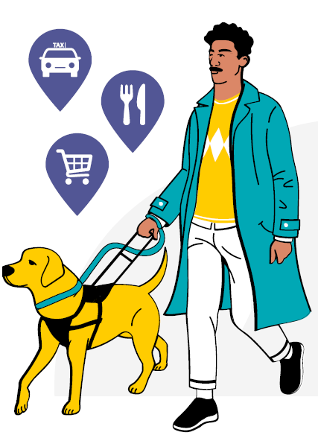
Did you know?
Customers with disabilities have a right to equal access to services like taxis, stores, and restaurants.
However, those with guide dogs often face discrimination when accessing these services.
You have a legal duty not to discriminate against customers.
You cannot refuse service because:
- You don’t like dogs
- You don’t want a dog in your car
- You think dogs are dirty
Refusing to allow a customer with a guide dog into your restaurant could be discrimination, which is illegal in British Columbia. People who use guide dogs have a human right to access services like taxis.

