Customers with guide dogs
  - Tips for the service industry
Everyone in B.C. has a human right to access services like restaurants and cafés without experiencing discrimination.


Greeting and seating
Say hello! Let the customer know you are there and identify yourself as their server. Ask if they need assistance getting to their table or seating area. Follow their directions.
Always talk to the customer, not their dog!

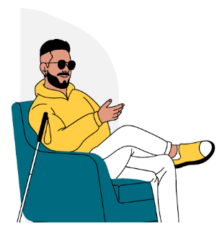
Menu and ordering
Always interact with the customer directly. Do not ask others at the table about what the customer needs or wants.
Ask if the customer requires assistance with the menu. They may ask you to read the menu or they may have already accessed it online. Start by telling them the sections of the menu (starters, mains, desserts, drinks) and asking which they would like you to read.

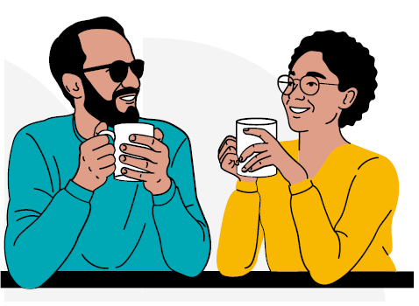
Serving and clearing
Always announce your arrival each time you approach the table and describe what you are doing.
Tell the customer where on the table you are placing any plates, glasses or utensils. If you move something on the table or clear anything, let the customer know.

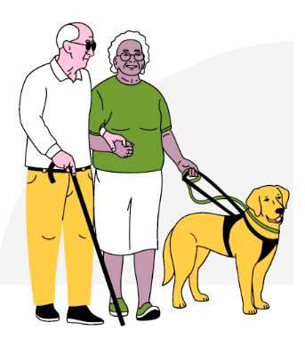
The cheque and paying
Ask your customer if they would like you to read the cheque to them and how you can assist them with the payment process.
If paying by cash, let the customer know what change you are handing back. If placing it on the table, tell them where.

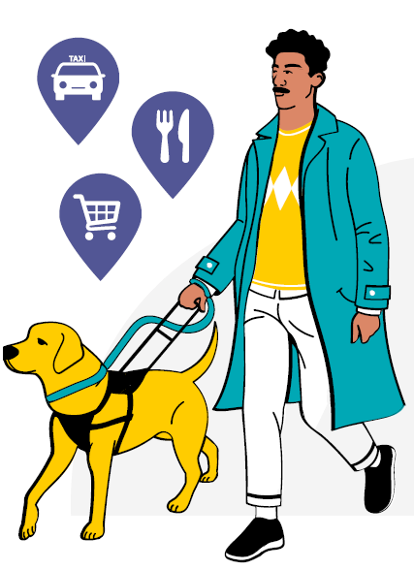
Did you know?
Customers with disabilities have a right to equal access to services like taxis, stores and restaurants.
However, those with guide dogs often face discrimination when accessing these services.
You have a legal duty not to discriminate against customers.
You cannot refuse service because:
- You don’t like dogs
- You don’t want a dog in your restaurant
- You think dogs are dirty
Refusing to allow a customer with a guide dog into your restaurant could be discrimination, which is illegal in British Columbia. People who use guide dogs have a human right to access services like restaurants.

